Futures TipsAdapter Elimination – W_MAIN Test Case

Test Environment Setup
- Configure the environment for W_MAIN Session.
- Make sure the Local Xtp in the environment is configured for W_MAIN
- Check the extent map to verify a path exists between local XTP and the trade servers.

Test Scenario 1
- Bring up the Product State Maintenance dialog in the Admin GUI.
- Pick a class running under the W_MAIN session. We will pick AAPL for this test case.
- Change the state of the future products and strategy products for AAPL to PreOpen. 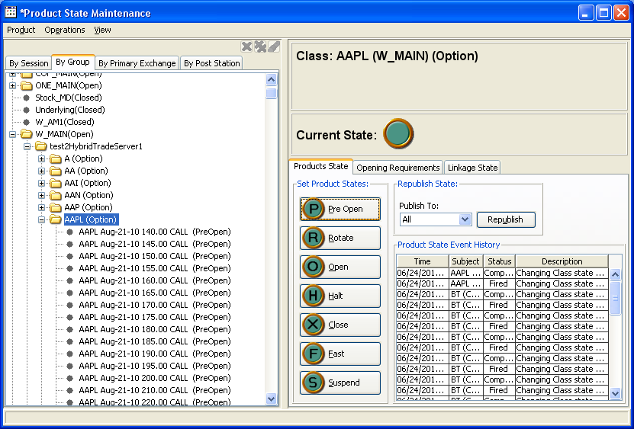

- From the local XTP fire an open messages indicating trade for AAPL.
- Verify the state of the option products and strategy products for AAPL changes to Open Rotation.
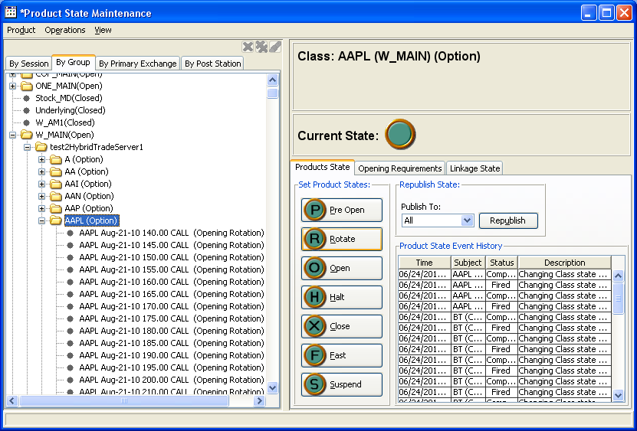
- Form the local XTP fire a halt message for AAPL.
- Verify the state of the option products and strategy products for AAPL changes to Halted 